LabVIEW
Laboratory Virtual Instrument Engineering Workbench is system design software for graphical programming from National Instruments. It helps to visualize configuration, measurement data, and debugging. It is used for data acquisition, instrument control, and signal processing.
The three main components of LabVIEW VI are:
- Front panel
- Block diagram
- Icon/connector panel
Learning outcomes:
- We have learnt about the LabVIEW and visual programming.
- Using LabVIEW we have so many programs like:
  - Mathematical addition, subtraction, multiplication and division.
  - Random number generation.
  - Temperature change from F to C.
  - Sorting number from an array.
  - Application of calculator with the help of case structure.
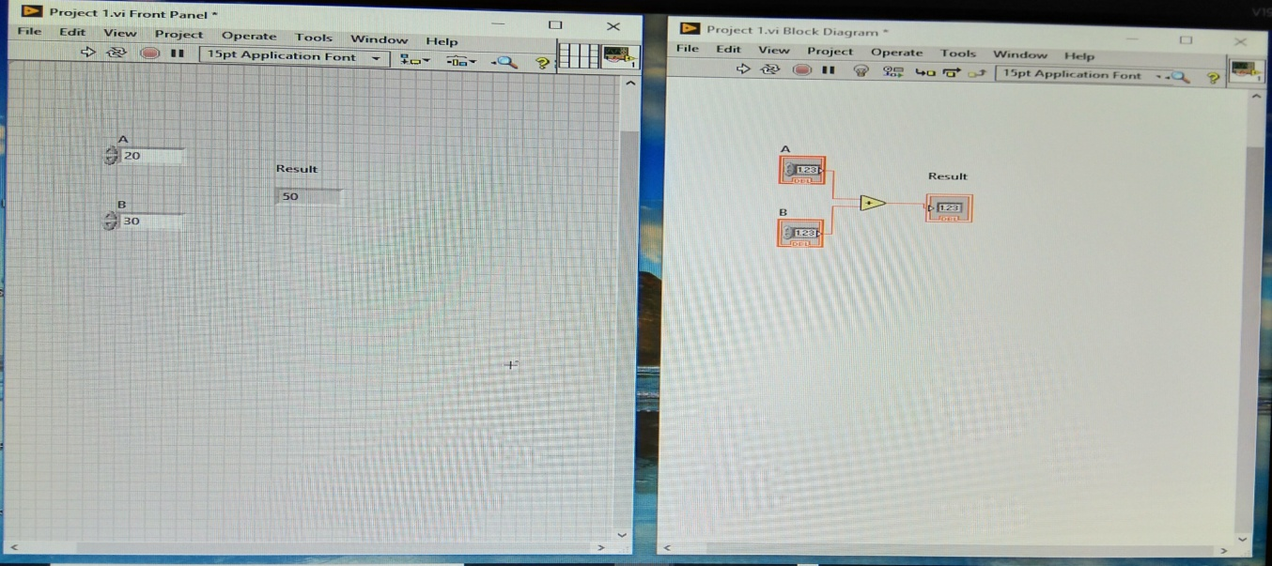
Fig 7.1: Mathematical addition in LabVIEW
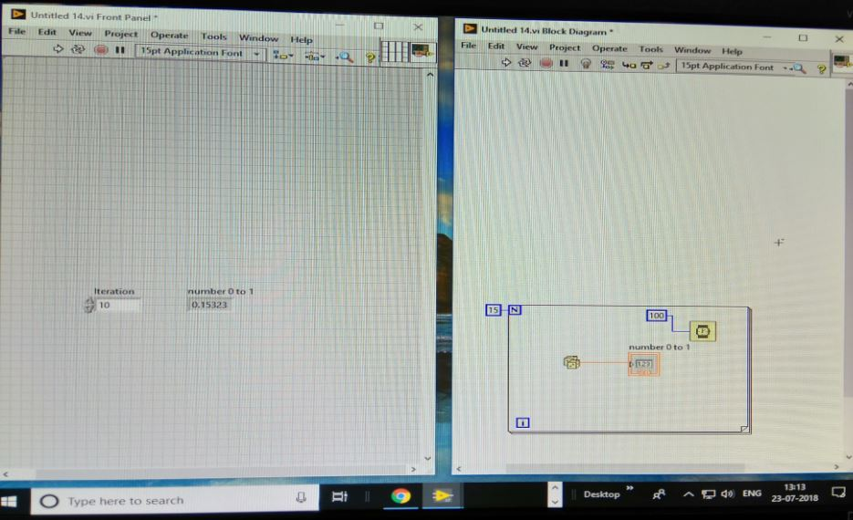
Figure 7.2: Random number generation
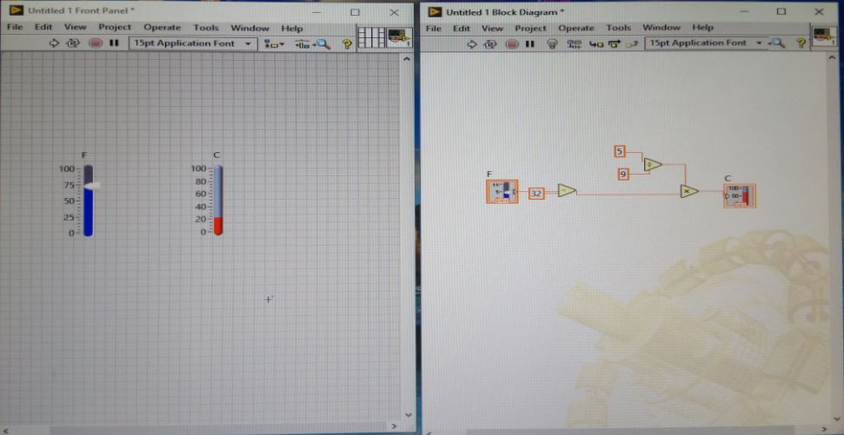
Fig 7.3: Temperature change from F to C

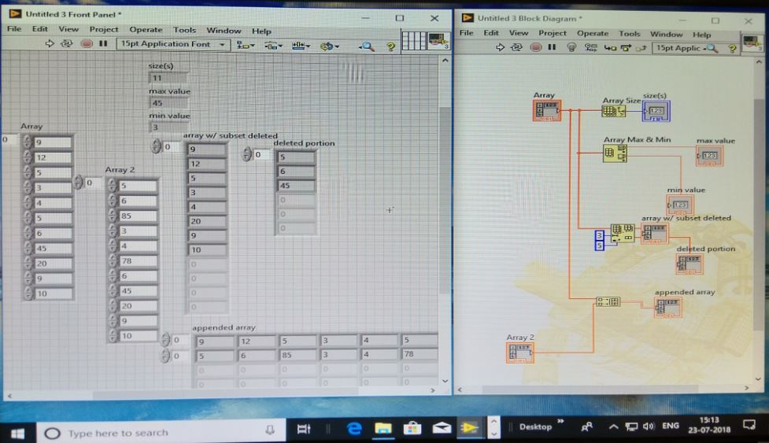
Fig 7.4: Sorting number from an array

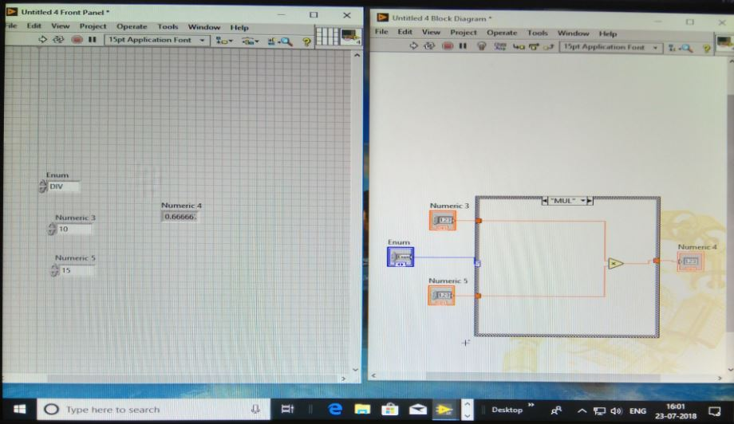
Fig 7.5: Application of calculator with the help of case structure
Data Acquisition
Data acquisition is the process of sampling signals that measure real world physical conditions and converting the resulting samples into digital numeric values that can be manipulated by a computer.
- Plotting time vs amplitude graph and filtering the signal.
- LED switch ON/OFF.
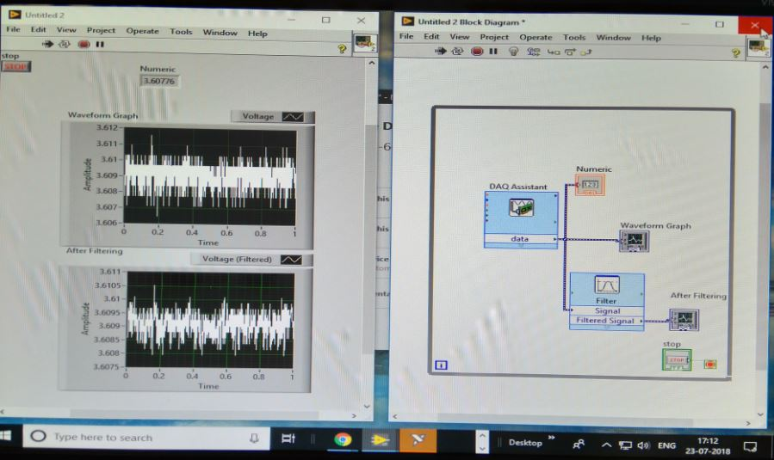
Fig 7.6: Plotting time vs amplitude graph and filtering the signal in LabVIEW
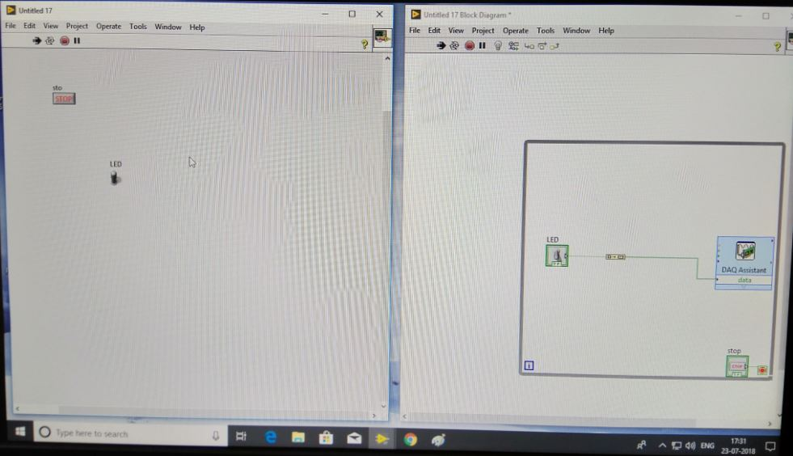
Fig 7.7: LED switch ON/OFF in LabVIEW

